

Project Initialization and Planning Phase

Date | 25 September 2026
Team ID | SWTID-2026-5836
Project Name | FitBuddy
Maximum Marks | 3 Marks

Define Problem Statements (Customer Problem Statement Template):
Create a problem statement to understand your customer's point of view. The Customer Problem Statement template helps you focus on what matters to create experiences people will love. A well-articulated customer problem statement allows you and your team to find the ideal solution for your customers' challenges. Throughout the process, you’ll also be able to empathize with your customers, which helps you better understand how they perceive your product or service.

Example:
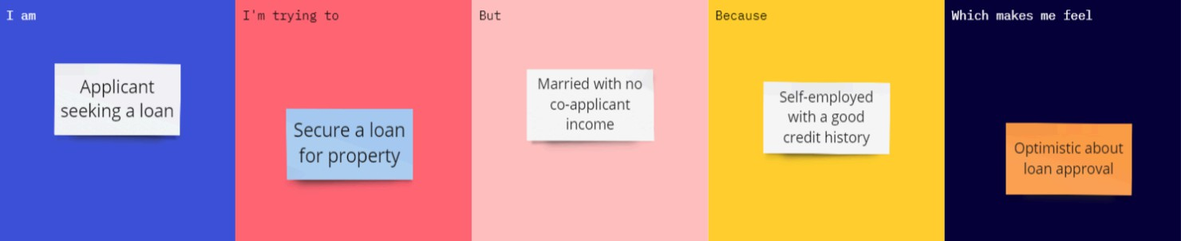

About the Project:
FitBuddy is a fitness companion app that gives users a simple, personalised 7-day workout plan based on their fitness goal, current level and the time they have each day. It removes the guesswork of what to do and when, so beginners and busy people can build a routine, stay consistent and see progress within a week.

Customer Problem Statements:

Problem Statement (PS) | I am (Customer) | I’m trying to | But | Because | Which makes me feel
PS-1 | A beginner who wants to get fit. | Follow a proper workout routine for the week. | I don’t know which exercises to do or how to plan them across the days. | Online fitness advice is scattered and not personalised to my level. | Confused and overwhelmed.
PS-2 | A working professional with a busy schedule. | Stay active with short daily workouts. | I can’t fit long gym sessions into my day. | Most fitness programs need more time and equipment than I have. | Frustrated and guilty about skipping.
PS-3 | Someone who often starts a fitness routine but quits. | Stay consistent for at least one week. | I lose motivation after a few days. | There is no clear day-by-day plan or way to track my progress. | Hopeful, but discouraged by past attempts.

